You’re invited to…

David’s Annual Drum Off!

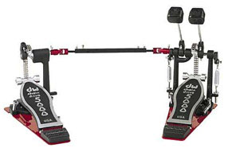

June 15th, 2007 at Coriander
Please RSVP by June 2nd

Please bring money to buy
Over priced food and
Beverages! Champagne
Too! (Only if you’re over 21)

